Lifecycle Processing Documentation

Overview & Notes

This document outlines the Lifecycle stages within Intercom’s Marketo instance, the system proxy triggers that define and cause leads to transition between stages and the processes and field updates associated with each Lifecycle Stage. Below are Intercom’s current Marketo Lifecycle stages, ordered not in their current order, but their recommended order:

1 - Prospect
2 - Sales Eligible Lead
3a - MQL-Trial
3b - MQL-Product
3c - MQL-Demo
3d - MQL-Nurture
3d - MQL-Trial: Qualified
4 - NON-SEL
5 - Customer
6 - Early Stage
7 - Former Customer
8 - Recycle

Intercom uses the lead field Lifecycle Status (L) to track Lifecycle Statuses; this configuration does not need to change.

This Lifecycle Status field does not necessarily need to be visible to the sales team, as the changes of the values are triggered through system proxies. The Lifecycle Status field is not meant to be manually changed by a human, or by any operational process outside of the Marketo Lifecycle Processing program. Intercom’s existing lifecycle adheres this best practice.

Intercom’s Existing Lifecycle Statuses for Processing within Marketo

In order to architect this single Lifecycle Status field, system proxies have been established for triggering each stage change. Below is the current mapping of the stages, the system proxies that define each stage, and the processes that are associated with each stage. Every lead within the Marketo database will be sorted into one of the following Lifecycle Stages based on the field proxies associated with the lead or contact.

1) Prospect
This is currently the ninth stage, but should be moved to the second first stage of the lifecycle funnel. Traditionally prospects are leads who have shown some behavioral engagement, but not enough to indicate they are ready for a Sales discussion. In Intercom’s instance, Prospect more signals that the lead is available to be marketed to. An immediate area of improvement is the addition of competitor and blacklist filters for leads that are not marketable.
Trigger: Person is created
Filters: Lifecycle Status (L) is empty
The normal flow of steps triggered by a Lifecycle Status change includes:
- Status Stamp (Separate campaign, requested)
- Date/time stamp (Separate campaign, requested by Status Stamp)

2) Sales Eligible Lead (SEL)
The second stage in this Lifecycle.
Triggers: Campaign is requested, SDR Segment changes to one of the following: ESB; MME; SMB; MM; ENT; SB, or MQL Date changes
Filters: Lifecycle Status (L) is Prospect or NON-SEL;
The normal flow of steps triggered by a Lifecycle Status change includes:
- Status Stamp (Separate campaign, requested)
- Date/time stamp (Separate campaign, requested by Status Stamp)

3a) MQL - Trial
This status indicates a qualified lead from a trial source
Trigger: one of the below data value changes
Data Value | New Value
Program Status is changed TRIAL | n/a
Fills out form: FORM Add-on Selection | n/a
SDR Segment | ENT  SMB  MME  SB  MM

Filters: Member of Smart List Lifecycle.MQL - Routable Leads (FY20); Program Status TRIAL was changed in the past 14 days
The normal flow of steps triggered by this campaign:
- Check for SDR segment to be Self-Serve or Very Small & Unknown, if yes REMOVE
- Changes Lifecycle Status (L) to MQL - Trial
- Date/Timestamp in MQL-Trial Timestamp field
- Requests 302 - MQL: Sync to SFDC smart campaign

3b) MQL - Product (Deprecated)
It appears that this status is to capture a geographically specific process.
Trigger: Campaign is requested
Filters: Member of Smart List Lifecycle.MQL - Routable Leads Free (FY 21); Country contains {Ireland, England, United Kingdom, Wales, Scotland}; SDR Segment IS NOT {Self-Serve, Very Small & Unknown}; Lifecycle Status (L) is Free; Member of Program is Free; Lifecycle Status (L) IS NOT {Sales Accepted Lead, Stage 1 Opportunity, Stage 2 Opportunity, Customer}

The normal flow of steps triggered by a Lifecycle Status change includes:
- Requests Emergency sync with SFDC if not created
- Waits for 10 minutes
- Removes from flow if the Lifecycle Status (L) is NOT Free
- Status Stamp to MQL-Product (in this flow)
- Date/time stamp (in this flow)
- Requests Redrip campaign

3c) MQL - Demo
This status indicates a qualified lead from a demo
Trigger: Fills out DEMO form; Demo Program OR G2Crowd Program Status is changed
Filters: Is Active User?=false; Is Owner Human=false; Email address not contains intercom; Company name is not Intercom; Lifecycle Status (L) NOT Sales Accepted Lead, Stage 1 Opportunity, Stage 2 Opportunity, Customer; First Name is not Empty; Last Name is not Empty; Country is not Empty; SDR Segment is SMB or MME or SB or ENT or MM
The normal flow of steps triggered by this Lifecycle Status change includes:
- Remove from flow if SDR Segment is Self-Serve or Very Small & Unknown
- Status Stamp (MQL-Demo)
- Date/time stamps (MQL-Demo Timestamp & Sales Eligible Timestamp if it’s in past before 1 day)
- Requests Salesforce Sync

3d) MQL - Nurture
This status indicates a qualified lead that is ready to be nurtured rather than passed to sales. DG Notes: Bad naming convention. Was generated from marketing based on combo of behavior and profile.

Trigger: Campaign is requested; Clicks Link in Email & Email name contains Autoprospecting; Score is changed - score is Fit OR Intent
Filters: Member of Smart List is “MQL - Nurture Candidates (FY21)” AND Lifecycle Status (L) is not Sales Accepted Lead OR Stage 1 Opportunity OR Stage 2 Opportunity OR Customer AND SDR Segment is SMB OR MME OR SB OR ENT OR MM
The normal flow of steps triggered by this Lifecycle Status change includes:
- Request Campaign (300a - MQL-Trial: Status Trigger) IF Member of Smart List is Lifecycle.MQL - Trials in the last 4d
- Remove from flow if member of Smart List is Lifecycle.MQL - Trials in the last 4d
- Status Stamp
- Date/time stamp
- Change data value of Nurture Trigger to {{trigger.trigger name}} - {{trigger.name}}
- Request Sync to SFDC

4) Non-Sales Eligible Lead (NON-SEL)
This status appears to be for smaller prospects who are routed to Self Serve processes rather than sales.
Triggers: Requested; SDR Segment changes TO Self-Serve OR Very Small & Unknown
Filters: SDR Segment IS Self-Serve OR Very Small & Unknown; Lifecycle Status (L) is NOT Customer or Early Stage
Flow:
- Stamp Status
- Date Stamp

5) Customer
Second to last in the lifecycle processing hierarchy. Once this is updated leads will qualify for this stage as long as they don’t qualify for any further stage in the Lifecycle funnel.
Trigger: Any of 4 data value changes listed below:

Data Value | New Value
App Status | Paying  Paying and Trialing
Matched Account Active App MRR | At least 1
Active App MRR | At least 1
Lifecycle Status (from Account) | Customer

Criteria field dependencies: Lifecycle Status (L) is not Early Stage, Customer
Stage field updates:
The normal flow of steps after Customer includes:
- If Lifecycle Status (L) is any (MQL-Trial, MQL-Nurture, MQL-Demo, MQL-Livechat, PQL, Self Service Lead, Self Service Trial) SET Person Status to Closed
- If Lifecycle Status (L) is any (MQL-Trial, MQL-Nurture, MQL-Demo, MQL-Livechat, PQL, Self Service Lead, Self Service Trial) SET Closed Reason to Existing Customer
- DateTime stamp

6) Early Stage
It is not clear what this stage indicates. Placement after Customer indicates it is likely a type of customer.
Trigger: Program Status is changed, program is Early Stage OR Added to App
Filters: Lifecycle Status (L) is not Early Stage AND Has App is True and Pricing Model is one of (Early Stage, Per Product Pricing Early Stage, Early Stage 99) OR Member of Program is Early Stage
The normal flow of steps triggered by a Lifecycle Status change includes:
- Status Stamp
- Date/time stamp

7) Former Customer
This status indicates a former customer.
Trigger: Data Value Active APP MRR Changes, New Value is 0, Previous Value is at least 1
Filters: Lifecycle Status (L) is Customer or Lifecycle Status (Account) is Customer
The normal flow of steps triggered by a Lifecycle Status change includes:
- Status Stamp
- Date/time stamp

8) Recycle
This status indicates a lead has gone through an unsuccessful sales cycle; there is also a separate feeder program for recycled leads from former customers that should be combined into a single program.
Trigger: Person Status is Closed
Filters: Closed Reason is not Existing Customer, Early Stage; Lifecycle Status (L) is Sales Accepted Lead; Lead Owner at Assignment is not empty
The normal flow of steps triggered by a Lifecycle Status change includes:
- Status Stamp
- Date/time stamp

Initial Processing
This part of the program is where people being created in the database are processed. It is intended to be the backbone of initial processing with other critical new lead items requested as part of the flow. The initial setting of a Lead Lifecycle status/stage is one of these items.
Trigger: Person is created
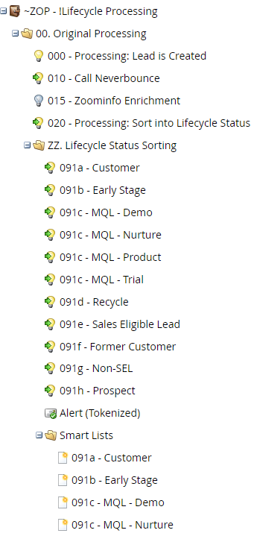
Initial processing starts with the 000 - Processing: Lead is Created. This smart campaign then requests any other processes that need to occur at the onset. In your instance this smart campaign also does the initial sync into Salesforce. This would often be done in a separate smart campaign for clarity but this is acceptable for efficiency and timing.
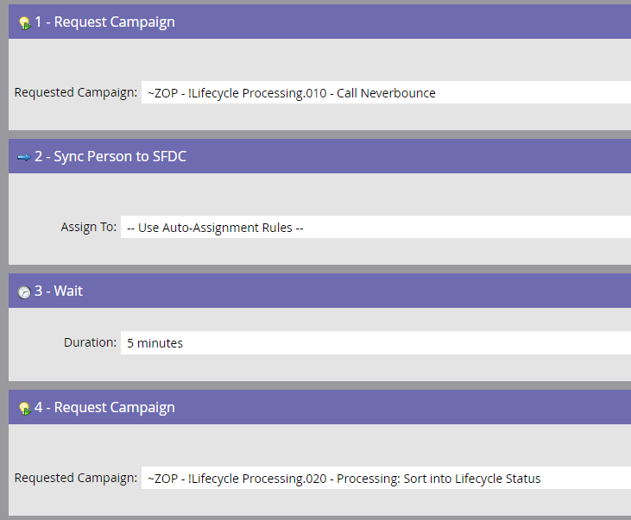
It is here (above) that the 020 - Processing: Sort into Lifecycle Status is requested. Below is the sorting flow.
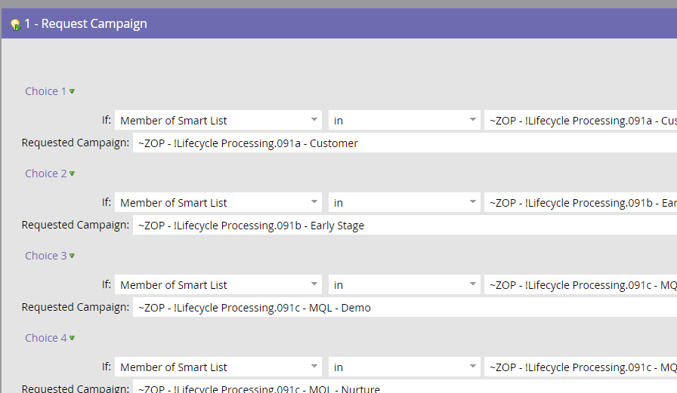

Sorting Smart Lists
091a - Customer - Filter Logic ANY:
- App Status is: Paying or Paying and Trialing
- Matched Account Active App MRR is at least 1
- Active App MRR is at least 1
- Lifecycle Status (from Account) is Customer
091b - Early Stage - Filter Logic ANY:
- Has App TRUE; Pricing Model is Early Stage, Per Product Pricing Early Stage or Early Stage 99
- Member of program TRUE; Program is Early Stage
091c - MQL - Demo - Filter logic ALL:
- Filled out form: FORM-Add on Selection
- Member of Smart List: Lifecycle.MQL - Routable Leads (FY20)
- Program Status was Changed: TRIAL, in past 14 days
091c - MQL - Nurture - Filter logic ALL
- Filled out form: FORM-Add on Selection
- Member of Smart List: Lifecycle.MQL - Routable Leads (FY20)
- Program Status was Changed: TRIAL, in past 14 days
091c - MQL - Product - Filter logic ALL
- Filled out form: FORM-Add on Selection
- Member of Smart List: Lifecycle.MQL - Routable Leads (FY20)
- Program Status was Changed: TRIAL, in past 14 days
091c - MQL - Product - Filter logic ALL
- Filled out form: FORM-Add on Selection
- Member of Smart List: Lifecycle.MQL - Routable Leads (FY20)
- Program Status was Changed: TRIAL, in past 14 days
091d - Recycle - Filter logic ALL
- Person Status is Closed
- Closed Reason is not Existing Customer or Early Stage
- Lifecycle Status (L) is Sales Accepted Lead
- Lead Owner at Assignment is not empty
091e - Sales Eligible Lead - Filter logic ANY
SDR Segment is (any of the following): ESB, MME, SMB, MM, ENT, SB
MQL Date is not empty
091f - Former Customer - Filter logic ALL
- Active App MRR is 0
- Customer Timestamp is not empty
091g - Non-SEL - Filter logic ALL
- SDR Segment is Self-Serve or Very Small & Unknown

